URL = <http://sotd.us/austinvanraden/CIS4655C-WebDev/Module%203/Activity/Mod3Activity.html>

Github repo = <https://github.com/AustinVanStroodleBerry/CIS4655C-WebDev/tree/master/Module%203/Activity>

Here is the webpage

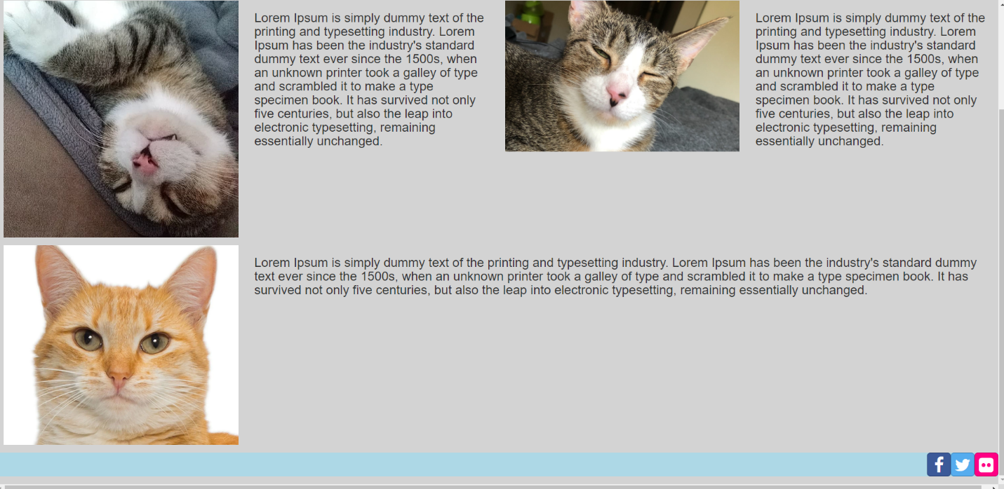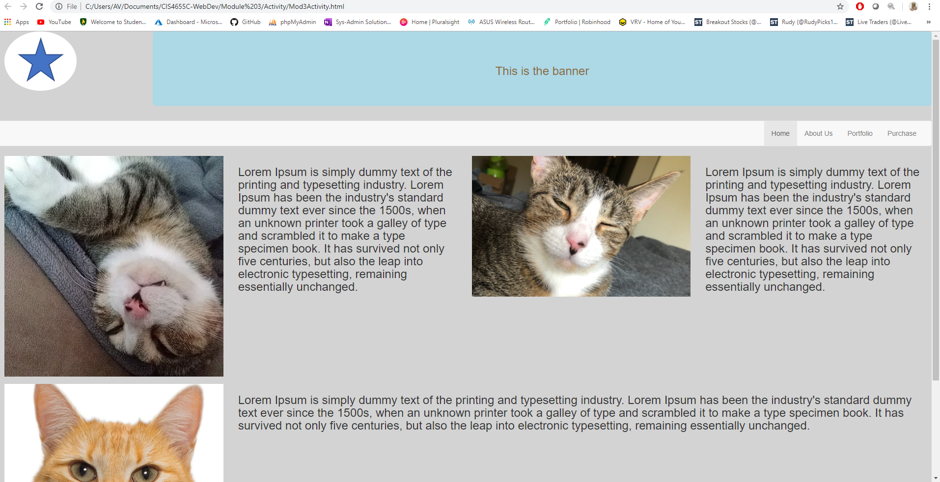

Ipad view

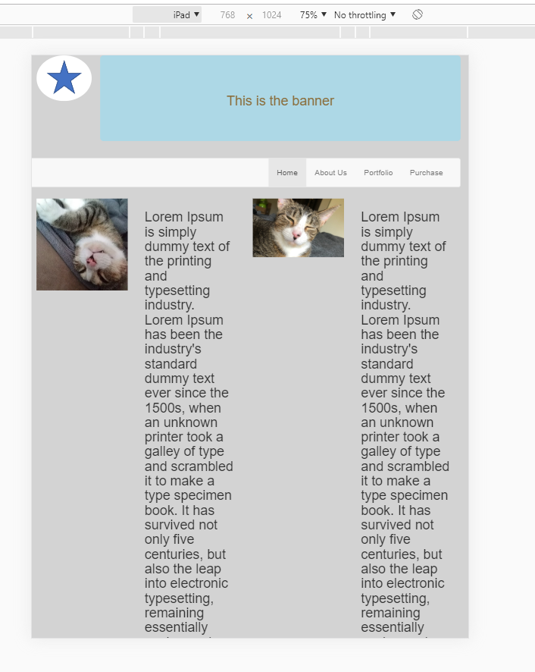

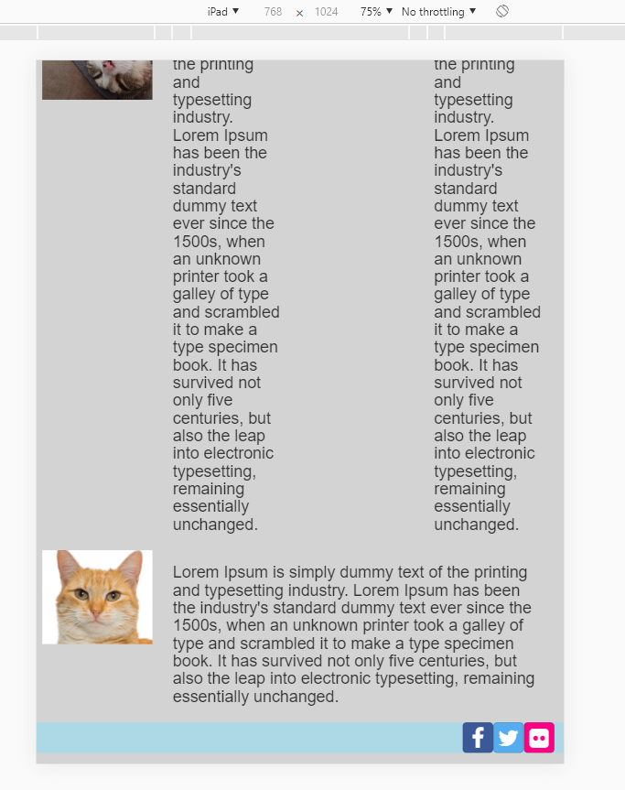

Galaxy S5 view

